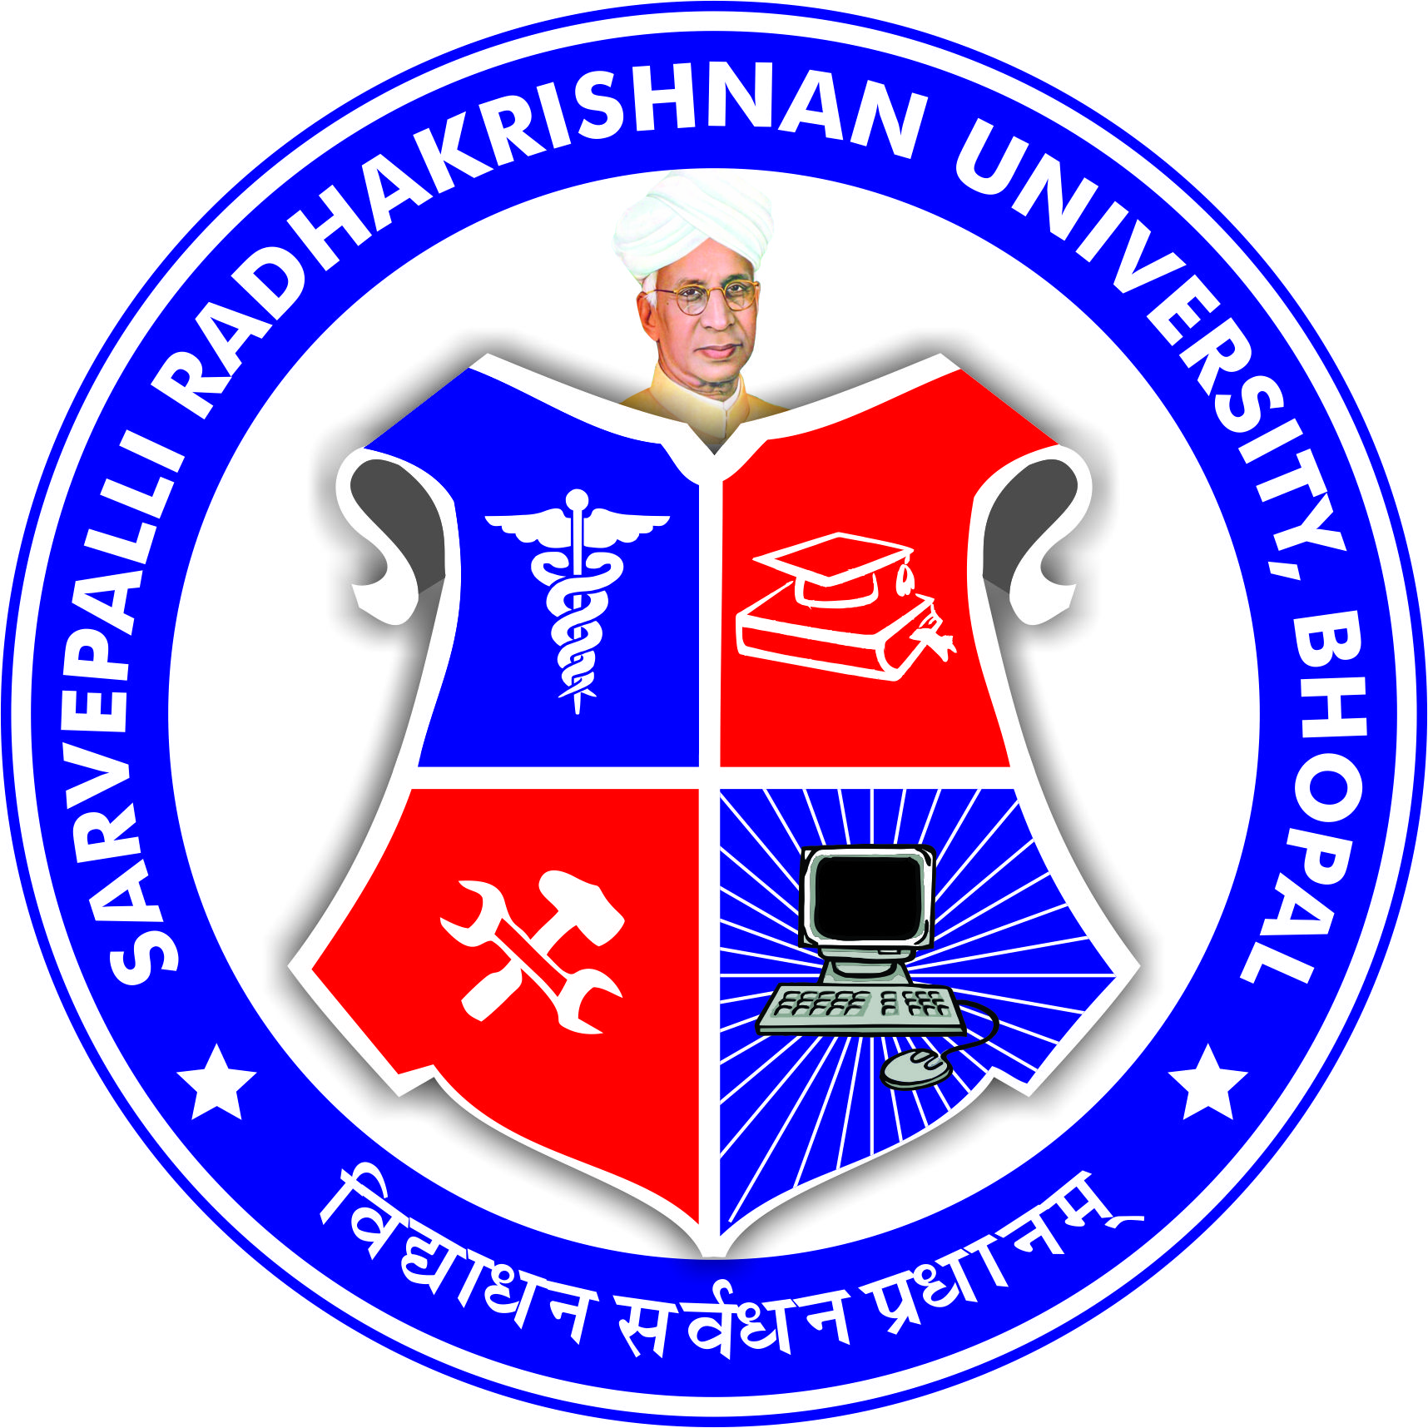
SARVEPALLI RADHAKRISHNAN UNIVERSITY
NH 12,RKDF IST CAMPUS, HOSHANGABAD ROAD, MISROD, BHOPAL (M.P.)
¼Statutory University established by Govt. of M.P. under section 2(F½ of UGC act)
Website: www.srku.edu.in, E-mail: info@srku.edu.in/srkubhopal@gmail.com
Phone: 0755-4700981 Fax: 07554700981

NO. DATE
Anti Ragging Committee
Order
Anti-Ragging committee of Sarvepalli Radhakrishnan University is here by reconstituted as below:
- Dr. Shivanand Bagewadi Chairman 9536158247
- Dr. Rishikesh Sharma Member 9977486482
- Mr. Kamal Niwaria Member 8770963551
- Dr. Varsha Namdeo Member 9131491965
- Dr. Rohit Swankar Member 9131773536
- Dr. Surbhi Singh Member 7354922607
- Dr. Narbada Gour Secretary 9691174770
- Ms. Riya Puse Student Rep. 6265988279
- Mr. Lalit Ahirwar Student Rep. 9171448964

Registrar

Copy to All Concern
Note- Secretary of the committee shall be responsible for conducting meetings & maintaining minutes of meeting.

SARVEPALLI RADHAKRISHNAN UNIVERSITY
NH 12,RKDF IST CAMPUS, HOSHANGABAD ROAD, MISROD, BHOPAL (M.P.)
¼Statutory University established by Govt. of M.P. under section 2(F½ of UGC act)
Website: www.srku.edu.in, E-mail: info@srku.edu.in/srkubhopal@gmail.com
Phone: 0755-4700981 Fax: 07554700981

NO. DATE
Anti-Ragging Squad
Order
Anti-Ragging Squad of Sarvepalli Radhakrishnan University is here by reconstituted as below:
- Dr. Dayashankar Pandey O/IC 9713076728
- Mr. Santosh Negi Member 7566863834
- Dr. Abhinav Dubey Member 9893400300
- Dr. Archana Selvan Member 9302255469

Registrar

